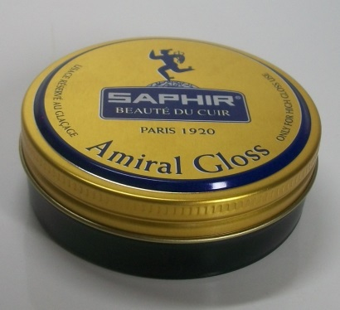
TECHNICAL CHARACTERISTICS

Specially formulated to meet the needs of individuals and professional polishers who want a quicker and easier glaçage than with the simple use of SAPHIR PATE DE LUXE. Indeed, SAPHIR PATE DE LUXE also has great cleaning and nourishing properties and therefore contains less hard and shiny waxes, but requires a little more controlled technique to make glaçage than the use of AMIRAL GLOSS specially formulated for this purpose.

AREA OF USE

This product is exclusively intended for obtaining a glaze on the outer ends and buttresses of the shoes that can only be glazed because the glaçage does not fit the folds of ease.

INSTRUCTIONS

1. The AMIRAL GLOSS applies after the maintenance of your shoes: see the TIPS section below.
2. Apply AMIRAL GLOSS with a cotton cloth stretched around your middle finger and forefinger, forming small circles on the parts to gloss. The pressure on the skin must be light because the sensation is very tactile. Renew the application. As soon as you feel resistance, drop a drop of water with your finger on the leather.
3. Lightly caress the leather with the same cloth, forming small circles. The goal now is to intensify the gloss of the glaçage and give a mirror effect to the shoe by repeating the previous actions ..
Glaçage is a slow operation; do not hesitate to switch between the right & the left shoe to let the layers dry.
4. Allow to dry for ½ hour without brushing the leather so as not to scratch the result.
Lightly polish with SAPHIR LUSTREUR GLOVE (reference 2520002)

ADVICE

We draw your attention to the fact that the AMIRAL GLOSS is in no way intended for the complete maintenance of the shoe but only for glaçage.

If your shoe is dirty (black marks ...) or dirty with waxy deposits, silicone or resin: it is important to clean the pores of the leather with the RENOMAT SAPHIR (code 0514). Make a test beforehand on a hidden part.

If your shoes are regularly maintained and do not require cleaning with RENOMAT, we recommend that you first use CREAM UNIVERSAL SAPHIR lotion (code 0904) or SAPHIR renovator jar (code 0122) that will rehydrate and gently clean the pores of the leather without altering the patina.

Before using the AMIRAL GLOSS, we recommend waxing your shoes by varying your maintenance by alternating use of:
¬ Surfine cream (code 0032) very nourishing and moisturizing thanks to its fluidity
¬ Pate de luxe (code 0002 or 0004) which makes it possible to obtain a deeper gloss and remains the essential of professional polishers.

We recommend the application of these products using the BRUSH POMMADIER (code 2600) which will allow, in addition to a very practical use, to also treat well the stem and the welt.

PACKAGING / PACKING
Contenance | PACKAGING |  |  | PACKING
Contenance | Type | Dimension mm |  | Quantity / box | Dimension mm
Contenance | Type | Diameter | height | Quantity / box | Length | Width | Height
50 ml | Screw lid tin | 70 | 22 | 12 | 149 | 149 | 72

GENCOD
DESIGNATION |  | Contenance | GENCOD
 |  | Contenance |  | Code article
 |  | Contenance |  | Code tarif
AMIRAL GLOSS | Black | 50 ml | 332401 | 0062 | 016
AMIRAL GLOSS | Neutral | 50 ml | 332401 | 0062 | 023

