TECHNICAL CHARACTERISTICS

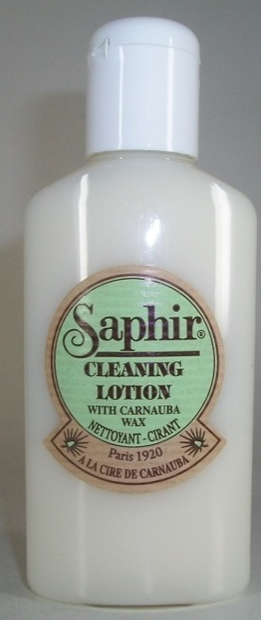
First cleaner in the SAPHIR range not classified at dangerousness level. This product is a very effective addition to the range of cleaning products offering an alternative to the use of RENO'MAT when it is not necessary to remove all the finishing products that have been applied to the surface of the leather. For consumers who regularly use the products SAPHIR without resin or silicone, and still want to clean them, the use of the CLEANING LOTION will allow to remove all types of soiling as well as the possible excesses of waxy deposits. The use of UNIVERSAL CREAM, in this case, proved definitely too soft. The CLEANING lotion offers this perfect compromise between these 2 products, one sometimes too strong, the other sometimes too soft. Its formula preserves the basis of the icings that have been made on the shoes which makes it possible to realize a new frosting more quickly. In addition it contains a significant amount of CARNAUBA wax which brings after polishing, protection and shine.

AREA OF USE

Smooth leather, oiled leather & nubuck, synthetic leather, skai, coated canvas including printed coated fabrics because this cleaner does not affect the printing.
Also suitable for white rubber soles and trainers. Especially recommended for shoemakers after repairing items to obtain quickly and easily an article corresponding to the image of a neat work that they wish to bring to their customers.

INSTRUCTIONS

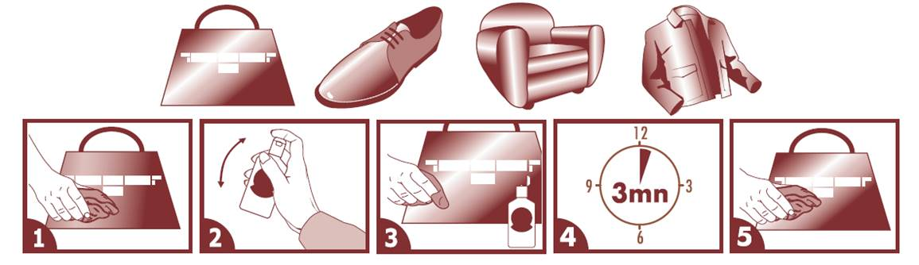

ADVICE

Once cleaned, the item can be simply polished with a cloth, or in order to achieve a perfect job, receive a product suitable for the support in the category total care of the SAPHIR range.
Make a test beforehand on a hidden part.

PACKAGING / PACKING

Contenance | PACKAGING |  |  |  | PACKING
Contenance | Type | Dimension mm |  |  | Quantity / box | Dimension mm
Contenance | Type | Width | Depth | Height | Quantity / box | Length | Width | Height
125 ML | Labelled PET bottle | 55 | 30 | 140 | 12 | 200 | 100 | 150

GENCOD
DESIGNATION |  | Contenance | GENCOD
 |  | Contenance |  | Code article
 |  | Contenance |  | Code tarif
CLEANING LOTION SAPHIR |  | 125 ml | 332401 | 0544 | 024

